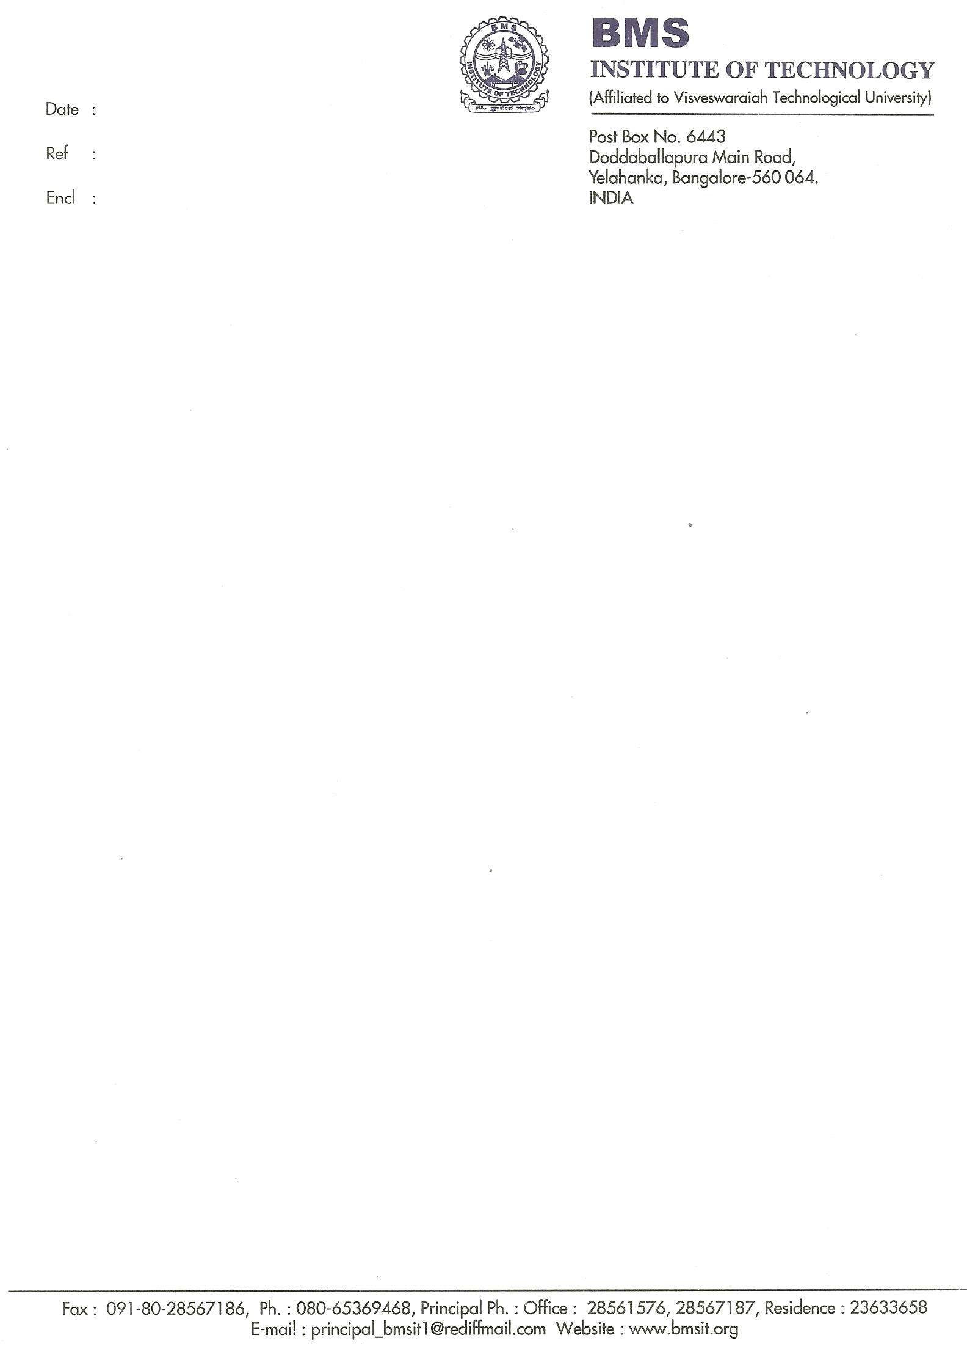

15/02/2011

Letter of Recommendation

It gives me great pleasure to recommend Mr. Venkatesh Kulkarni with whom I have been associated as a professor for the past 4 years and I am well acquainted with his academic and non academic qualifications. He is an intelligent and a hard working student.

He has a sound foundation in the subjects and his academic performance in the same is commendable. His methodical approach enabled him to get a firm grip on the core subjects. He behaves professionally both in laboratory and lecture classes. He is an active participant in classroom activities. At the laboratory he would maintain precise up-to-date records.

He has shown a deep and abiding interest in the experimental and practical aspects of the subject along with sincerity and hard work reflecting his potential. Also during my association with him in his course of study, he has impressed me with his diligence, persistence, and maturity of thought and zest for knowledge.

Overall, Venkatesh has a charismatic personality. I rate him among the best students in his class. I am confident that Mr. Venkatesh Kulkarni with his sincerity, determination and exemplary intellectual abilities would prove to be an asset to your university. With these credentials I rank him among the top 3% of the students in his class and put forth my recommendation for his admission at your esteemed university.

Sincerely,
Ambika
Professor, Dept. of Telecommunication
B.M.S. Institute of Technology
E-mail:

